VDI Usage & Performance Analysis Report (2015)

Executive Summary & Data Methodology
Analysis of server logs from the Virtual Desktop Infrastructure will benefit the Chief Information Officer in the capacity planning and management of licenses. The boundaries of the study will be strictly limited to the VDI computers (prefix "CMU") in the fiscal year of 2015.
A pre-processing audit of the information showed two important points that affect the results. Firstly, the information available dates from January 1st, 2015, up until August 28th, 2015. No information was available from the fall term (September to December). This automatically makes the information about the "Annual" performance shown below valid for only an 8-month period. Secondly, there were about 16% of the application logs where the stop time recorded were invalid (for example, "1900-01-01"), likely due to the applications hanging or being timed out. To avoid distorting the performance information, only the incomplete files were dropped when calculating performance but were retained when calculating the number of users.
General Usage Findings
During the first eight months of the year 2015, the total number of unique users handled by the VDI solution has been (3013). The average number of users handled daily by the system has been (139), and the maximum number of users handled in a day has been (577). The above statistics indicate that the system has been handling the average number of users and has the capability of handling the maximum number of users.
Specific User & Application Analysis
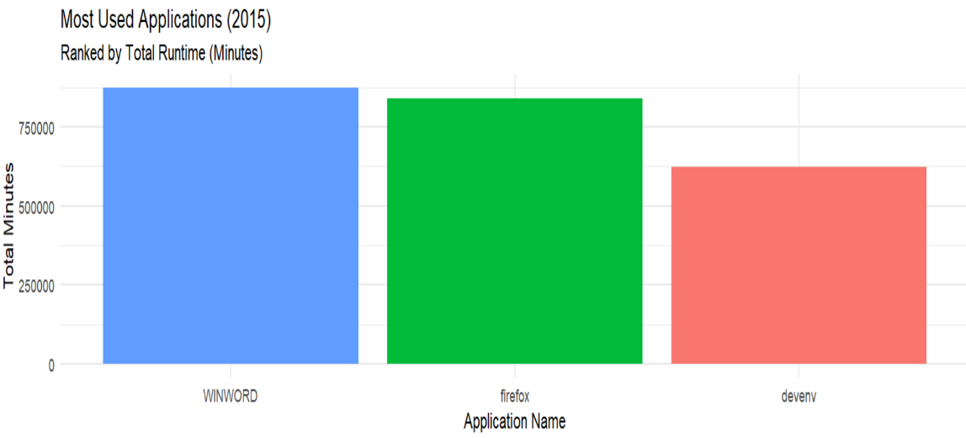
Figure 1: Top 3 Applications by Runtime Duration (Jan-Aug 2015)
To identify user behavior, the research focused on the pattern of users logging in through Windows Remote OS. The user who logged in most was [userid5179], totaling [2695] login instances. Regarding demanding software usage, the three software applications used longest in the network are (WINWORD), (Firefox), and (Devenv). These three applications represent the primary drivers of active runtime and licensing demand on the network. (Figure 1).
Strategic Recommendations & Risk Assessment
Beyond standard usage metrics, the analysis uncovered three critical areas where IT intervention is recommended to improve system stability and performance:
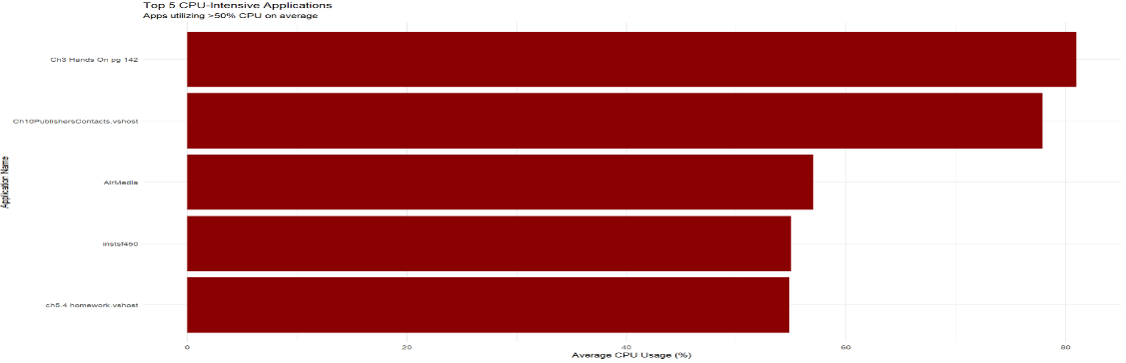
Figure 2: CPU Intensity Analysis showing student coursework causing performance spikes
- Mitigate the "Noisy Neighbor" Risk (CPU Optimization): The results showed that the maximum CPU usage is not being caused by conventional productivity applications but rather the student assignment executable files (for example, ‘ch5.4 homework.vshost’, ‘Ch3 Hands On’). These applications' CPU usage remains above 80% on average. They should be run in the "High Performance" server pool because they are intensive development applications. This will ensure that the university's applications remain unharmed even if university students deploy sub-optimally coded applications. (Refers to Figure 2.)
- Investigate System Stability: The 16% rate of invalid stop times (crashed sessions) is abnormally high for a production environment. I recommend the Infrastructure Team investigate whether this is caused by a specific VDI configuration error or user behavior (such as users closing the VDI window without logging off), as this represents a significant "hidden" load on the servers.
- Address the Q4 Blind Spot: Although the data source only goes through August, the reported "Total User" number almost certainly reflects less than the yearly number because it doesn't factor in the beginning of the fall term. The licenses purchased in 2016 should not be determined solely from this information: An extrapolation factor must be applied because of the missing data from Sept through Dec.

Appendix: R Analysis Script (Please refer to the attached. Rmd and Knitted HTML file for the complete reproducible code used to generate these findings.)

